**Installation Location Photo for West Sacramento Site**

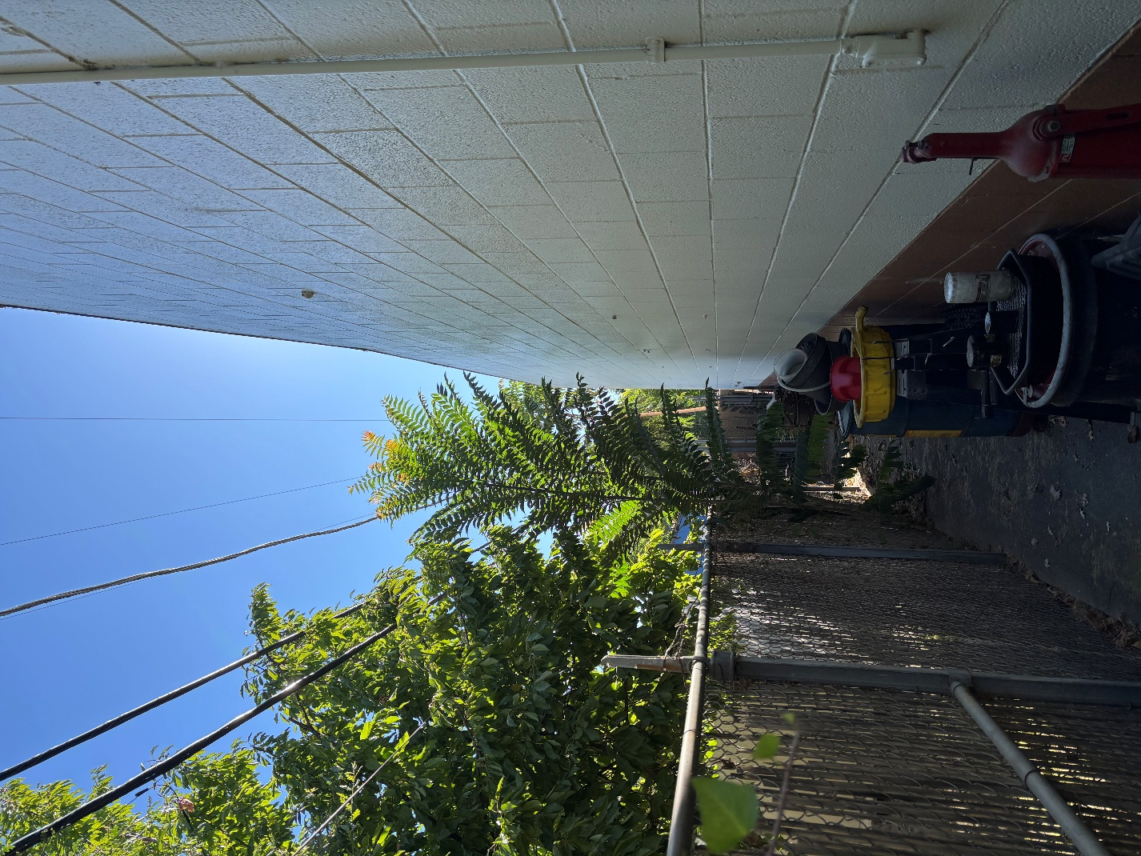

**Woodland Site Photo**

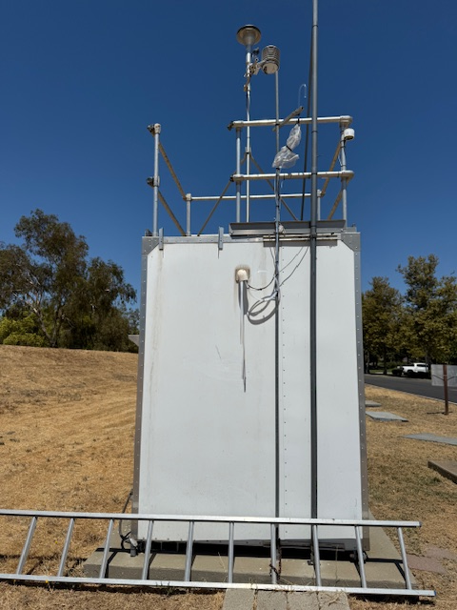

**Vacaville Site Photo**

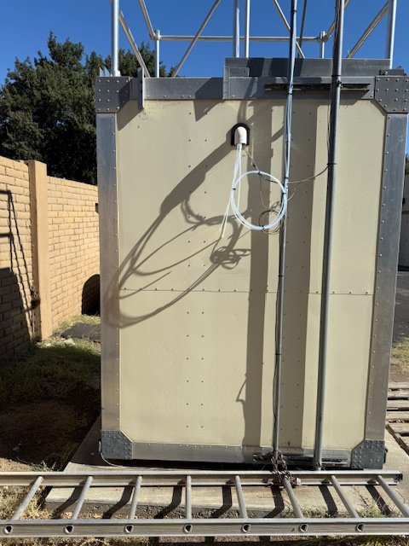

**Example Acceptable Ladder Photo**

